
SIMATS ENGINEERING
ASSESSMENT TOOL 2

COURSE CODE: CSA14 COURSE NAME: Compiler Design

COURSE OUTCOME COVERED
CO1: Apply lexical analysis for token specification and recognition using LEX tool (BL3)
Assessment Tool Weightage: 20%

QUESTIONS: 3 Total Marks:50
Annexure A
ERROR ANALYSIS TASK

Code of Conduct:
I Bandari Lakshitha Sankar Reddy(192571085) (Name / Reg No) certify that this submission is my original work and that I have adhered to the guidelines specified for this assessment.
I understand that any violation of academic integrity rules will result in disciplinary action.

Signature of the student: Lakshita.B

Q1. The following program is intended to perform simple arithmetic operations, function calls, array access, and looping constructs. However, the code contains multiple errors introduced at different phases of compilation, including lexical, syntax, semantic, logical, and runtime errors.
Description:
The given C program performs array processing, function calling, arithmetic operations, conditional checking, and pointer operations. The program contains multiple errors at different stages of compilation and execution. The errors are identified using GCC in VS Code and then corrected to obtain successful execution.
Code:
#include <stdio.h>
int sumArray(int arr[], int n) {
int i, sum = 0;
for(i = 0; i <= n; i++) {
sum = sum + arr[i];
}
return sum;
}
int main() {
int arr[5] = {1,2,3,4,5}
int total;
total = sumArray(arr);
if(total == 15) {
printf("Correct Sum\n")
}
int a = 10, b = 0;
int c = a / b;
int *p;
*p = 20;
return 0;
}
Error (gcc Q1_error.c -o Q1)
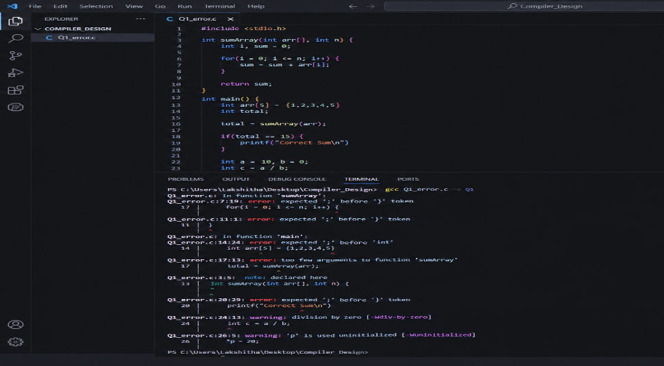

Corrected code:
#include <stdio.h>
int sumArray(int arr[], int n) {
int i, sum = 0;
for(i = 0; i < n; i++) {
sum = sum + arr[i];
}
return sum;
}
int main() {
int arr[5] = {1, 2, 3, 4, 5};
int total;
total = sumArray(arr, 5);
if(total == 15) {
printf("Correct Sum\n");
}
int a = 10, b = 2;
int c = a / b;
int value = 20;
int *p = &value;
printf("Division Result: %d\n", c);
printf("Pointer Value: %d\n", *p);
return 0;
}
Output:
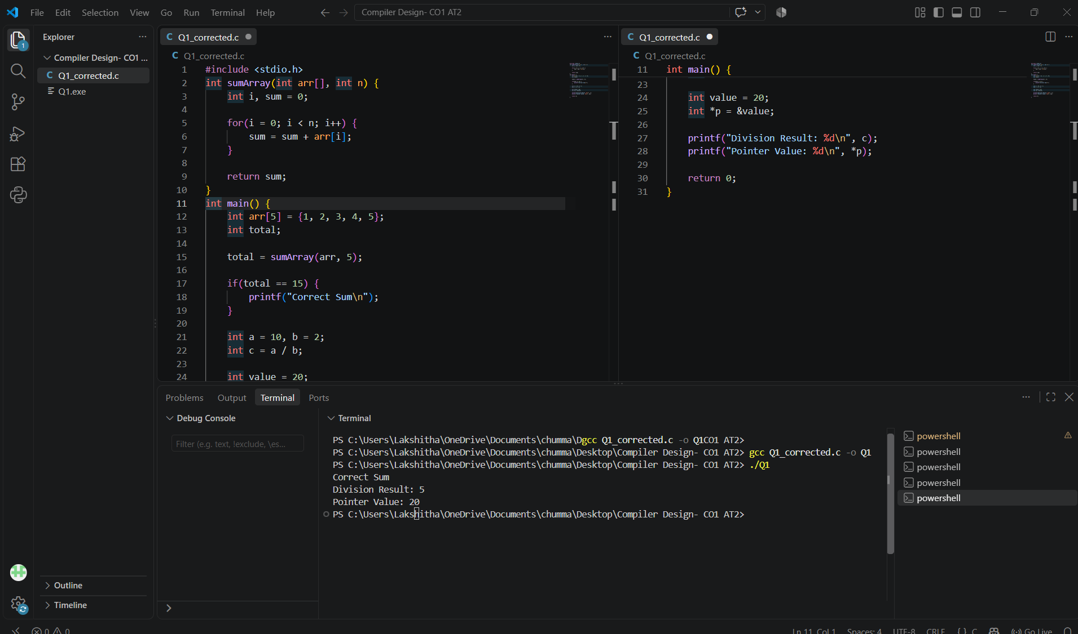

Q2.The following C program contains multiple lexical errors introduced intentionally. These errors occur due to invalid tokens, incorrect identifiers, malformed constants, and illegal symbols, which are typically detected during the lexical analysis phase of a compiler. Carefully examine the program and answer the questions given below.
Description:
The given program contains intentionally invalid tokens such as identifiers beginning with digits, illegal symbols, malformed numeric constants, and incomplete string/character literals. The program is compiled using GCC in VS Code to identify the errors. After correcting the invalid tokens, the program is compiled and executed successfully
Code:
int main() {
int 1num = 100;
float rate@ = 25.5;
char ch = 'abc';
int total = 50$20;
int num#1 = 30;
int %count = 40;
printf("Welcome to Compiler Design);
int x = 09;
int y = 0xZ12;
int z = 12.3.4;
char str1[] = "Hello;
char str2[] = "World";
int _valid = 10;
int invalid-id = 20;
float value = 5..6;
int data = 10@5;
char c = 'xy';
int 3value = 60;
printf("Value: %d\n", total);
return 0;
}
Errors:
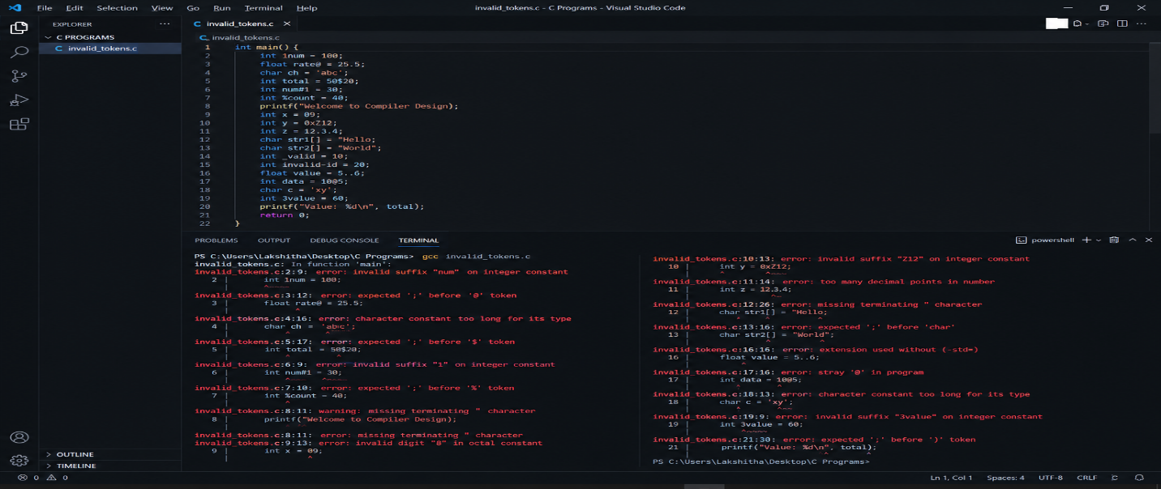
Corrected code:
#include <stdio.h>
int main() {
int num1 = 100;
float rate = 25.5;
char ch = 'A';
int total = 50 + 20;
int num1_value = 30;
int count = 40;
printf("Welcome to Compiler Design\n");
int x = 9;
int y = 0x12;
float z = 12.34;
char str1[] = "Hello";
char str2[] = "World";
int _valid = 10;
int invalid_id = 20;
float value = 5.6;
int data = 10 + 5;
char c = 'X';
int value3 = 60;
printf("Value: %d\n", total);
return 0;
}
Output:
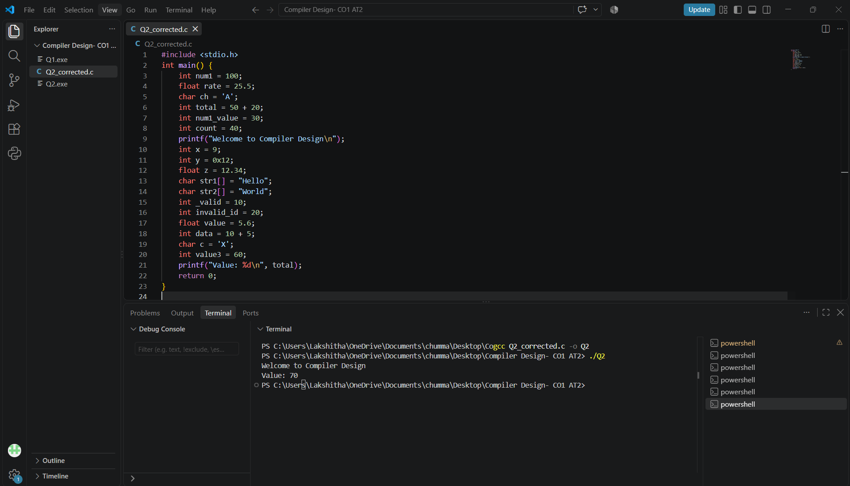

3. Q3. The following C program is designed to perform arithmetic operations, function calls, conditional checks, pointer usage, and looping. However, the program contains multiple errors distributed across different phases of a compiler, including:
Description:
The program performs arithmetic operations, function calls, conditional checking, pointer operations, array access, and looping. The errors are identified using GCC in VS Code and the program is then corrected for safe execution
Code:
#include <stdio.h>
int divide(int a, int b) {
return a / b
}
int main() {
int #value = 20;
float num = 15.5
int result;
result = divide(10);
if(result = 5) {
printf("Result is 5\n")
}
int x = 10;
int y = 0;
int z = x / y;
int arr[4] = {1,2,3,4};
printf("%d\n", arr[4]);
int *ptr;
*ptr = 25;
int total;
total = x + y * result + 0;
while(x < 20) {
printf("%d\n", x);
}
return 0;
}
Errors:
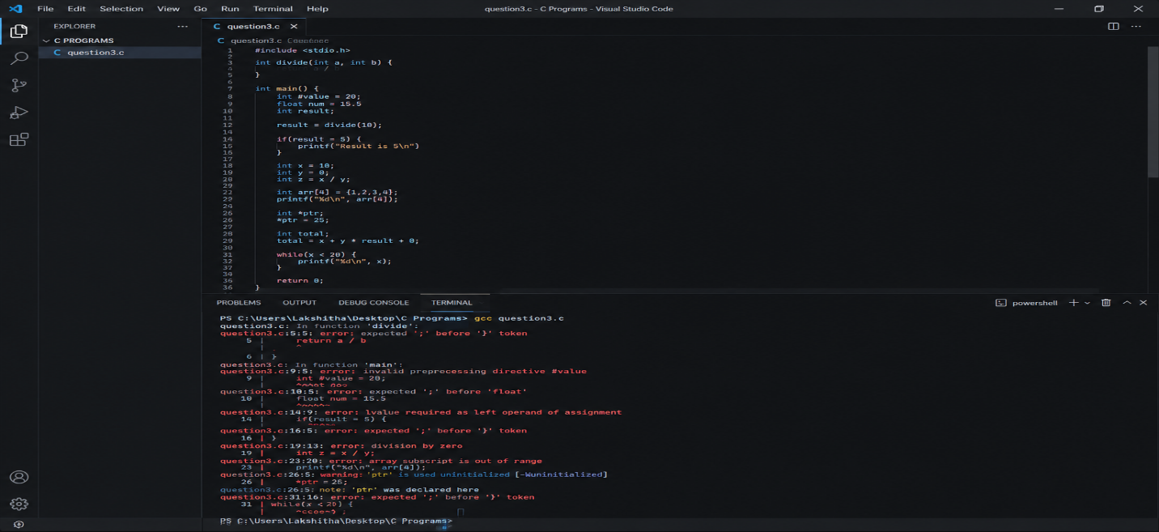
Corrected code:
#include <stdio.h>
int divide(int a, int b)
{
return a / b;
}
int main()
{
int value = 20;
float num = 15.5;
int result;
result = divide(10, 2);
if (result == 5)
{
printf("Result is 5\n");
}
int x = 10;
int y = 0;
int z;
if (y != 0)
z = x / y;
int arr[4] = {1, 2, 3, 4};
printf("%d\n", arr[3]);
int ptr_value = 25;
int *ptr = &ptr_value;
printf("%d\n", *ptr);
int total;
total = x + y * result + 0;
while (x < 20)
{
printf("%d\n", x);
x++;
}
return 0;
}
Output:
